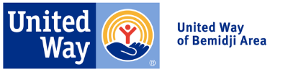
2023 Campaign Email Templates

How to Use Templates

Keep your United Way campaign top of mind for your employees! Consider using these suggested emails to craft your own communication plan.
- Links to suggested videos and tools are included, but you may want to remove if you have shared these videos/tools in a different format (such as at a kickoff).

Pre-Kickoff/Welcome Message

Subject Line: It’s Almost Time for our United Way Campaign!

Dear [First Name],

United Way of Bemidji Area is how our community comes together to address our toughest issues – but they couldn’t do this important work without you.

Through strategic partnerships and collaborative work, United Way brings the many voices of the Bemidji Area together to find common ground and develop strategic plans for change. Your commitment to this year’s campaign will give your neighbors the programs and services they need to live healthy lives and thrive.

Take a look at their Impact Report and mark your calendars for the start of [Company Name]’s United Way charitable giving campaign on [Campaign Start Date].

Together we can do more than any one of us can do alone.

P.S. Follow United Way of Bemidji Area on Facebook, Instagram, and Email Newsletters to stay up-to-date!

Kickoff Email

Subject Line: United Way Campaign Kick-Off!

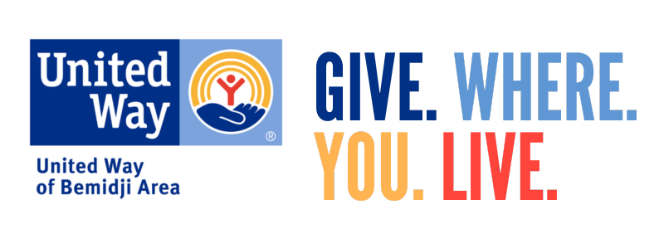

Today marks the start of [Company Name’s] 2023 United Way Campaign! And we’re calling on each and every employee to come together and contribute to addressing the Bemidji Area’s greatest needs.

Together, we are making a difference in our community. Please donate today. [Add how to make a gift, for example through online or paper pledge form]

[Closing],

Midterm Email

Subject Line: Every dollar makes a difference

[Salutation],

As our United Way Campaign is nearing the end, we want to make sure you have a chance to help address the Bemidji Area’s greatest needs. Even the smallest gift can add up to big wins for our community.

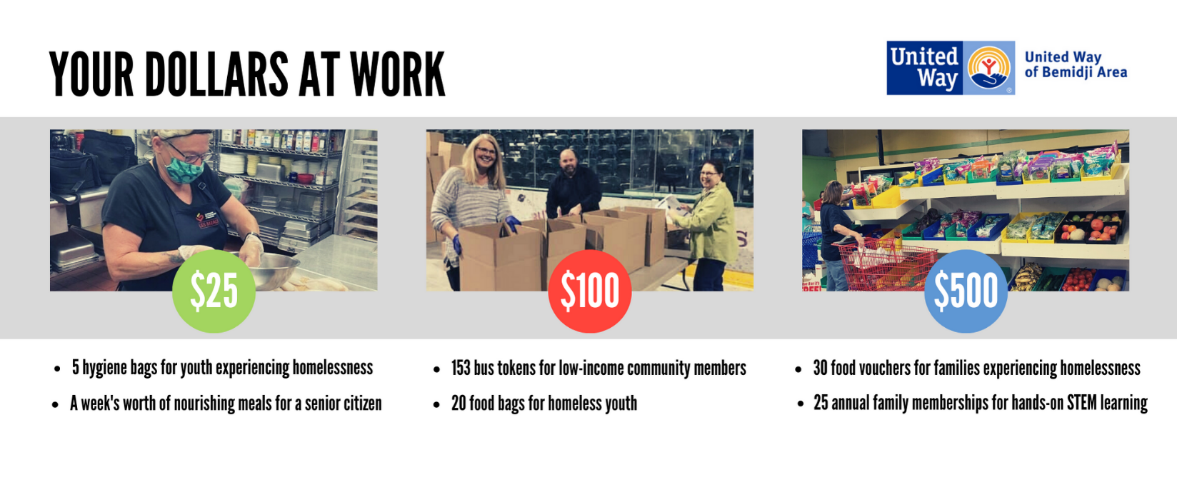
[Add how to make a gift, for example through online or paper pledge form]

Thank you.

[Closing],

P.S. Follow United Way of Bemidji Area on Facebook, Instagram, and Email Newsletters to more opportunities to give, advocate, and volunteer!

Last Chance Email

Subject Line: It’s never too late to Live United

[Salutation],

I’m so proud of the progress we’ve made with our United Way campaign! A reminder that our United Way campaign is wrapping up on [XYZ date.]

There is still a chance to support the United Way and their Partner Agencies who impact more than 60,000 people in our community each year! Learn more about the United Way Partner Agencies here.

[Add how to make a gift, for example through online or paper pledge form]

[Closing],

